01.

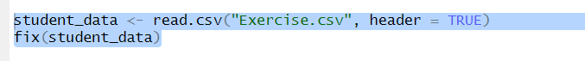

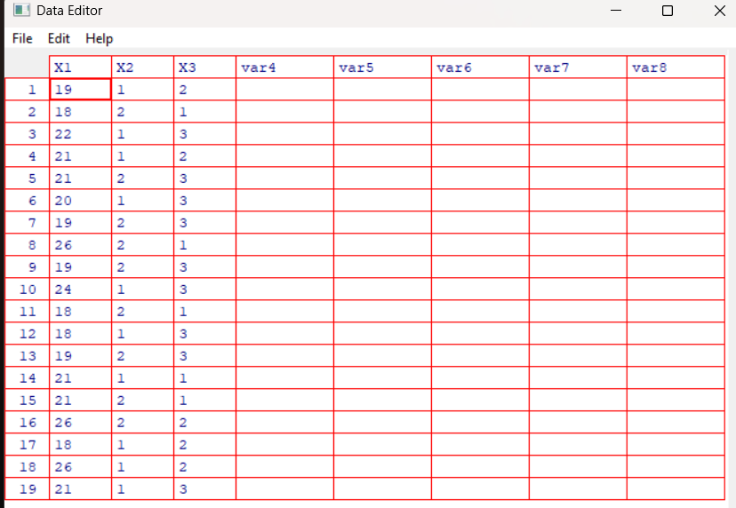

02.

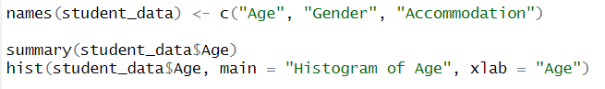

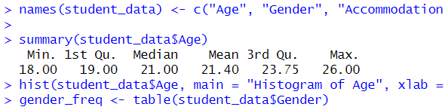

03.

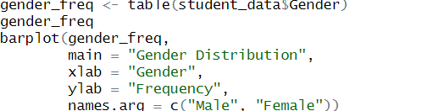

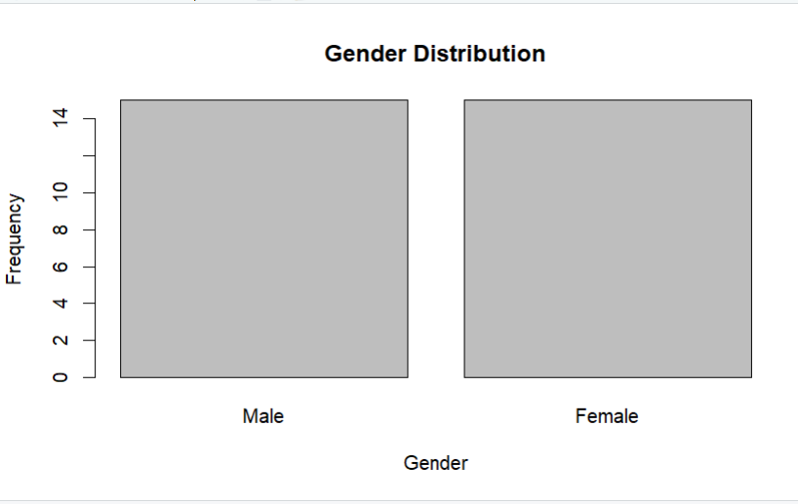

04.

